ARTAUD, ANTONIN (1896-1948)

Antonin Artaud was a French writer and theatre-maker of the early twentieth century. His work includes manifestos, correspondence, poetry, criticism, drama, film acting, and theatre directing. His impassioned writing combines impulses of historical avant-garde movements and the apocalyptic atmosphere of the interwar era. His legacy in the world of arts and letters is that of a visionary: his creative output, largely unedited, is scattered across genres but unified by a set of themes, obsessions, and impulses, such as the split between ‘real’ life and social life and the need for violence to regenerate civilization.

Born in Marseilles in 1896, Artaud spent much of World War I in a sanatorium, where he developed a life-long addiction to opiates. He moved to Paris in 1923, working in theatre there for the next thirteen years with major experimental directors including Georges Pitoëff and Charles Dullin and acting in films directed by Carl Dreyer, Abel Gance, and Fritz Lang. Suffering setbacks in his financial and artistic life, he travelled to Mexico in 1936 to participate in the peyote rituals of the Tarahumara Indians. His mental health, never strong, deteriorated quickly around this time. He spent from 1937 to 1946 in asylums. When he was transferred to a clinic near Paris in 1946, he was greeted with enthusiasm by artists who had read his work while he was confined.

Artaud's early prose, poetry, and theatrical writings (1925-27) staged a revolt against traditional forms of expression, articulating an obsession with the rift between thought and language. He was briefly affiliated with the Surrealists, who were also exploring alternatives to rational, language-based expression. Artaud ran the Théâtre Alfred Jarry with Roger Vitrac and Robert Aron from 1927 to 1929, and he directed and acted in his own adaptation of The Cenci in 1935.

Artaud's most influential work, The Theater and Its Double (1938), articulates his disgust with theatrical standards and Western civilization and calls for a new theatrical language ‘halfway between gesture and thought’ (Selected Writings, 242). He argues that society must be reconnected with its lost spirit through an overwhelming crisis like the plague. What he called the ‘Theater of Cruelty’ would play this role, surrounding the spectator, assaulting the senses, and circumventing rational thought and language in order to touch ‘that fragile, fluctuating center’ (Theater and Its Double, 13 that he saw as the essence of life.

Artaud spent the World War II years in various asylums, during which time he was initially catatonic, then gradually recovered enough to draw and write again. These asylum writings include text-on-ink portraits, letters containing spells and curses, and postcards to public figures, including Hitler. In 1947, he returned to dramatic writing with To Have Done With the Judgement of God, a radio play composed of invented language, percussion, and poetry.

Artaud's influence permeated experimental theatre of the 1960s. Theatre artists including Jean Genet, Jean-Louis Barrault, Judith Malina, Julian Beck, and Peter Brook testify to his influence in moving theatre away from its foundations in playwriting and toward an emphasis on directors, image, sound, and movement.

List of Works

Artaud, Antonin. (c. 1956-1994) Oeuvres complètes d’Antonin Artaud, nouvelle édition revue et augmentée, vols. I-XXVI, Paris: Gallimard.

----- (1968-73) Collected Works of Antonin Artaud, vols. 1-4, trans. Victor Corti, London: Calder and Boyars.

----- (1976) Selected Writings, trans. Helen Weaver, ed. and intro. Susan Sontag, New York: Farrar, Straus and Giroux.

----- (1958) The Theater and Its Double, trans. Mary Caroline Richards, New York: Grove Weidenfeld.

References and Further Reading

Blanchot, Maurice. (1956) ‘Artaud,’ La Nouvelle revue française 4.47 (November): 873-81.

Derrida, Jacques. (1978) ‘The Theater of Cruelty and the Closure of Representation’ and ‘La
Parole soufflée,’ Writing and Difference, trans. Alan Bass, Chicago: University of Chicago Press.

Finter, Helga. (1997) ‘Antonin Artaud and the Impossible Theatre: The Legacy of the Theatre of Cruelty,’ TDR 41.4 (Winter): 15-41.

Jannarone, Kimberly. (2011) Artaud and His Doubles, Ann Arbor: University of Michigan Press.

Penot-Lacassagne, Olivier. (2005) Artaud et les avant-gardes théâtrales, Paris: Lettres Modernes Minard.

Plunka, Gene A., ed. (1994) Antonin Artaud and the Modern Theater, Cranbury, NJ: Associated University Presses.

Virmaux, Alain. (1970) Antonin Artaud et le théâtre. Paris: Seghers.

Kimberly Jannarone, University of California, Santa Cruz

Recommended Illustrations
[Note: Please use one of the images of Artaud as a younger man (preferably the photo by Man Ray) , plus the image of him as an older man, to show the rapid change in his appearance in a short period of time.]

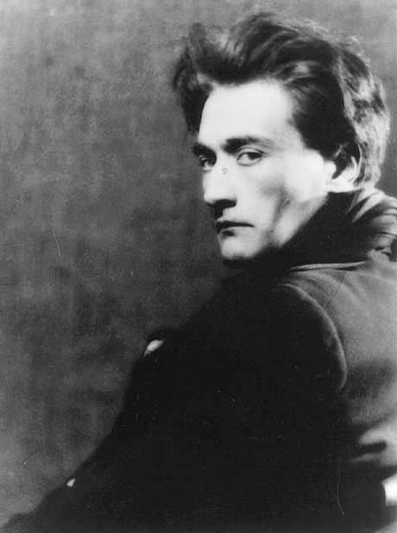
Antonin Artaud in a photo by Man Ray, 1926.
[Available at: http://en.wikipedia.org/wiki/File:Artaud_manray.jpg]
and http://www.manray-photo.com/catalog_gp/popup_image.php?pID=619&image=0 ]

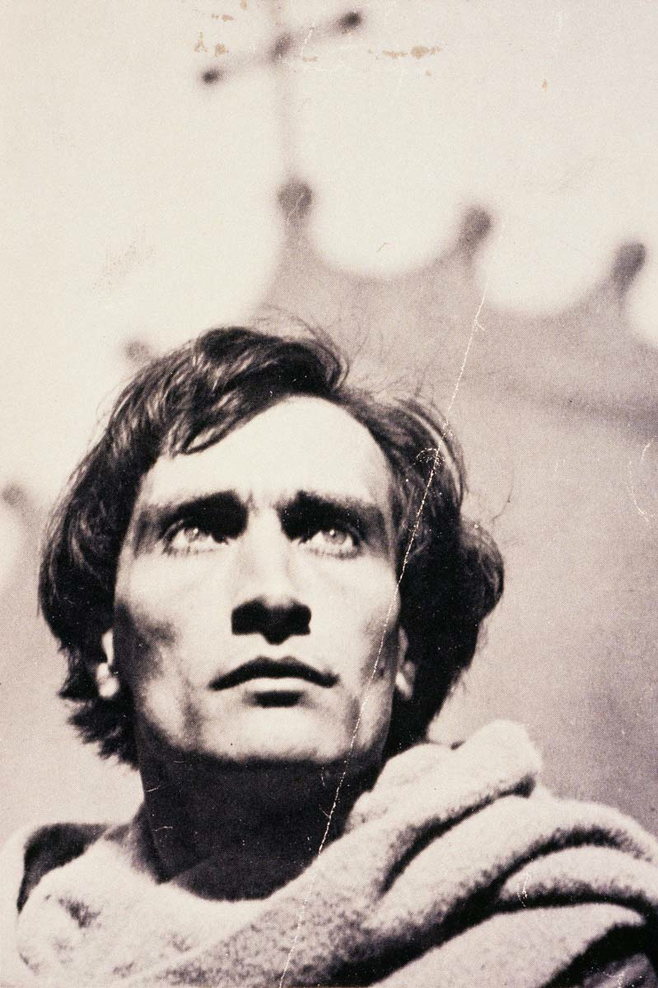
Antonin Artaud in the film The Passion of Joan of Arc (1928), directed by Carl Dreyer.
[This is the image used for the cover of Artaud: Collected Works, edited by Susan Sontag. It is available at: http://www.eltonyoga.com/vajrayogini/wp-content/uploads/2012/06/Artaud_thought_image.jpg]

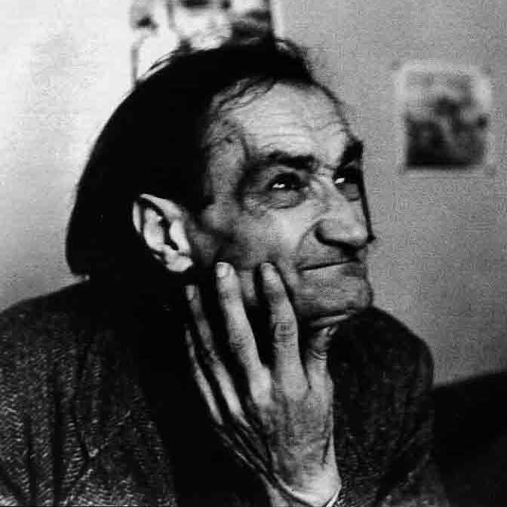
Artaud near the end of his life, at an asylum in Ivry.
[A series of this and similar photos are published at the end of the Grove Press edition of The Theater and Its Double. It is available at: https://rosamondpress.files.wordpress.com/2012/05/antonin-artaud.jpg]

